LAB 2

1.INFIX TO POSTFIX CONVERSION.

OUTPUT:

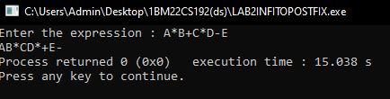

CODE NEXT PAGE:

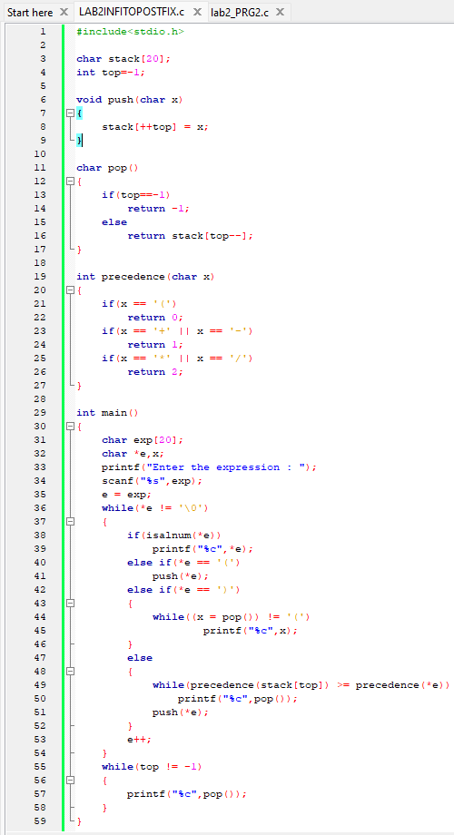

PRG2: POSTFIX EVALUATION

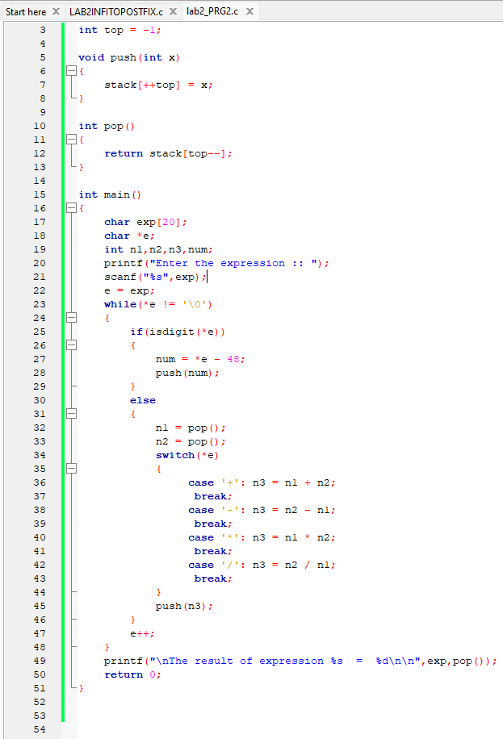

OUTPUT:

